Figure-1.4.1. Add Instance window showing vpulse1 (NAND Input A)

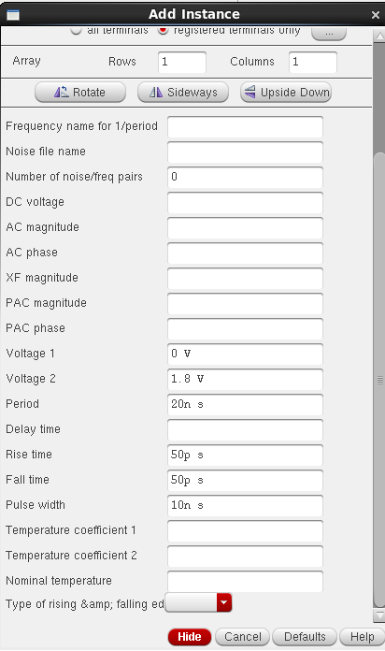

Figure-1.4.2. Add Instance window showing vpulse2 (NAND Input B)

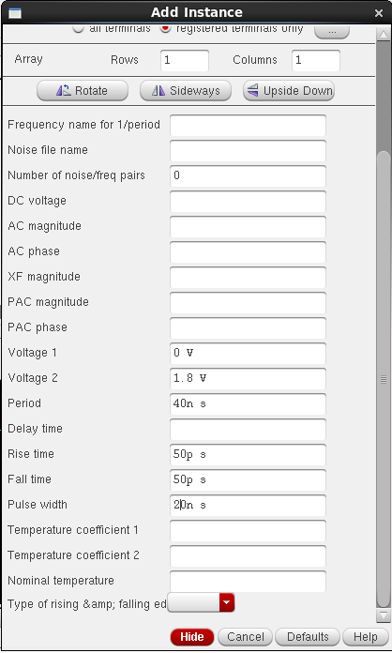

Figure-1.4.3. Add Instance window showing vdc (NAND inverter_test VDD)

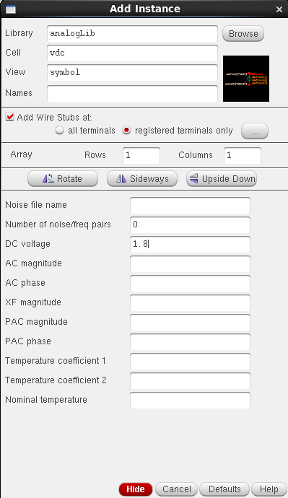

Figure-1.2. Complete transistor-level schematic of the CMOS AND inverter
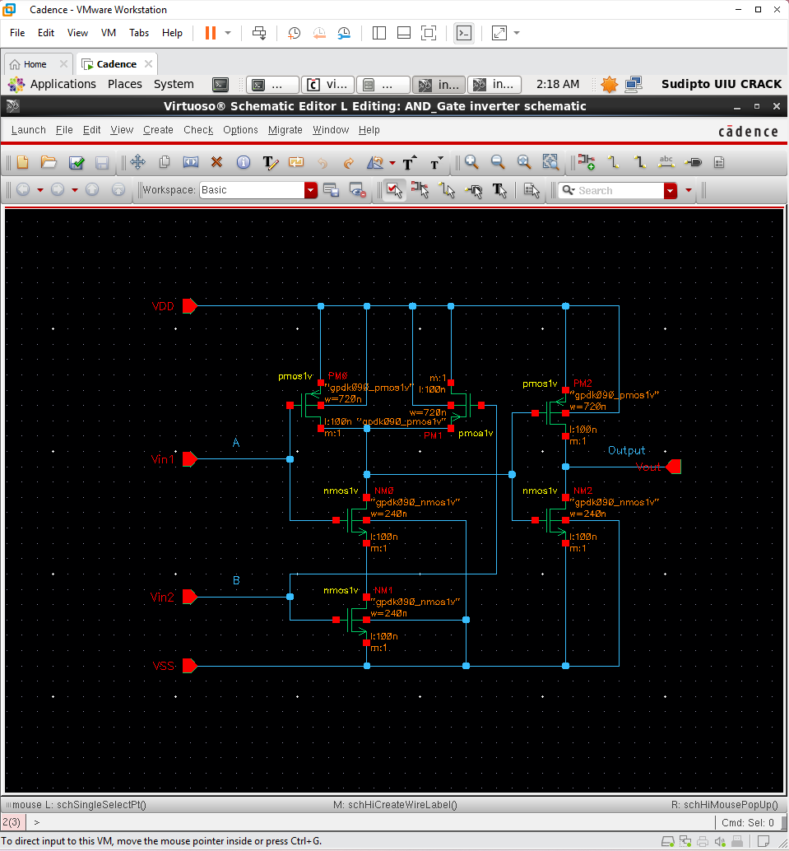

Figure-1.3. Generated schematic symbol of the CMOS AND inverter
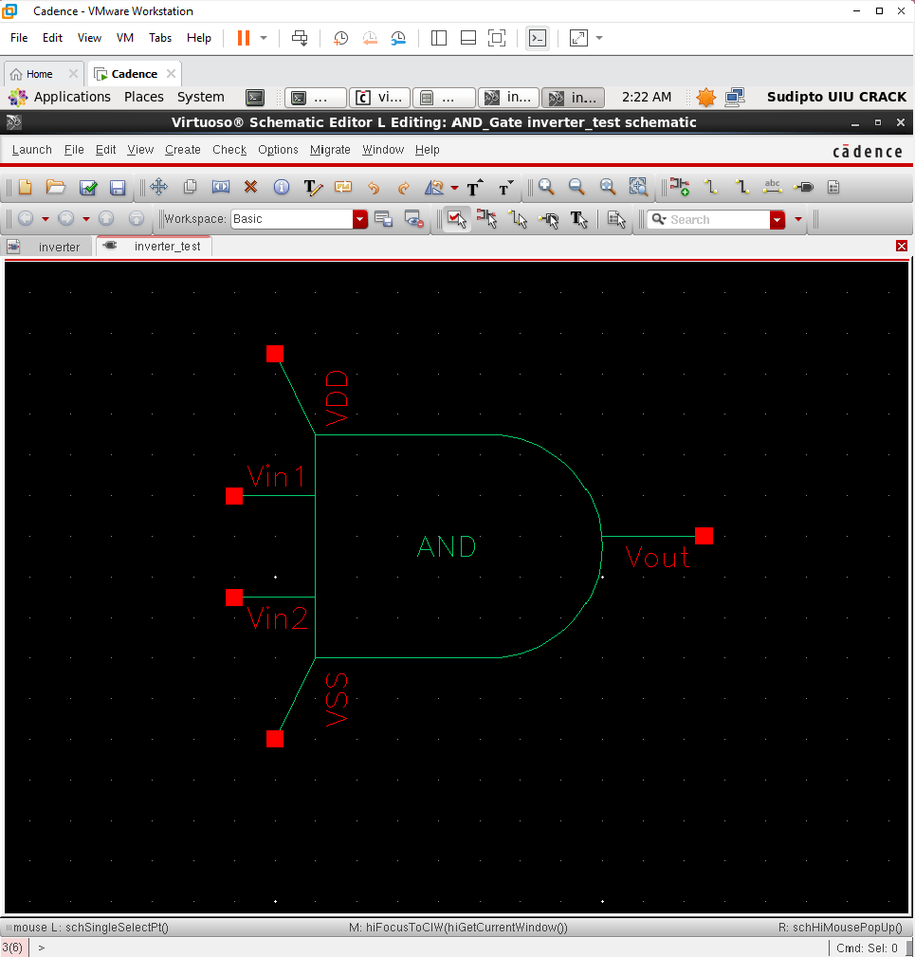

Figure-1.4.4 Test bench schematic (AND inverter_test)
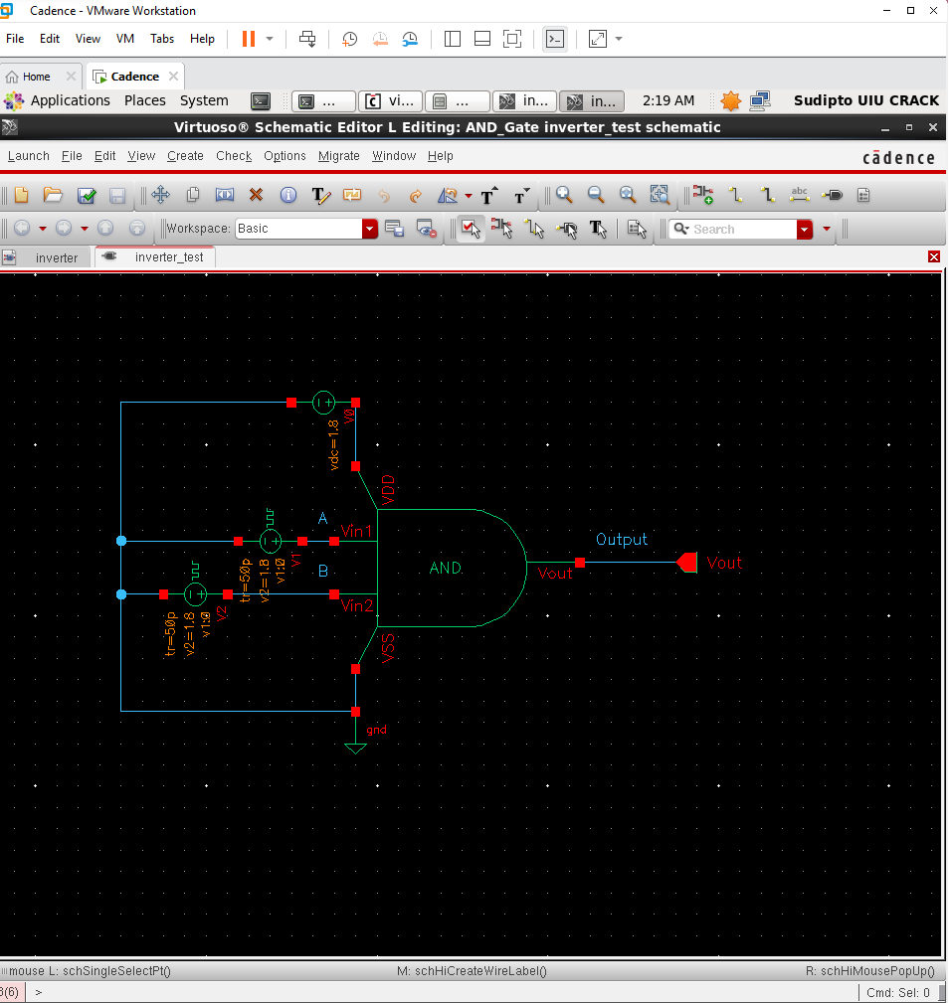

Figure-1.5. AND Simulation results
